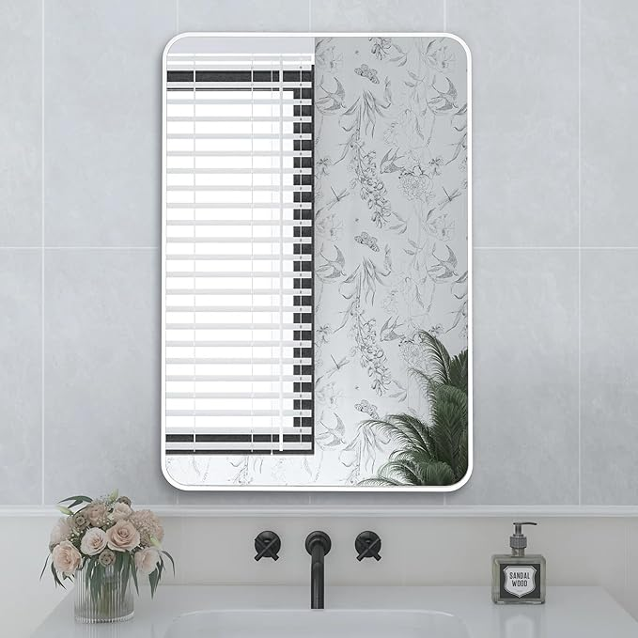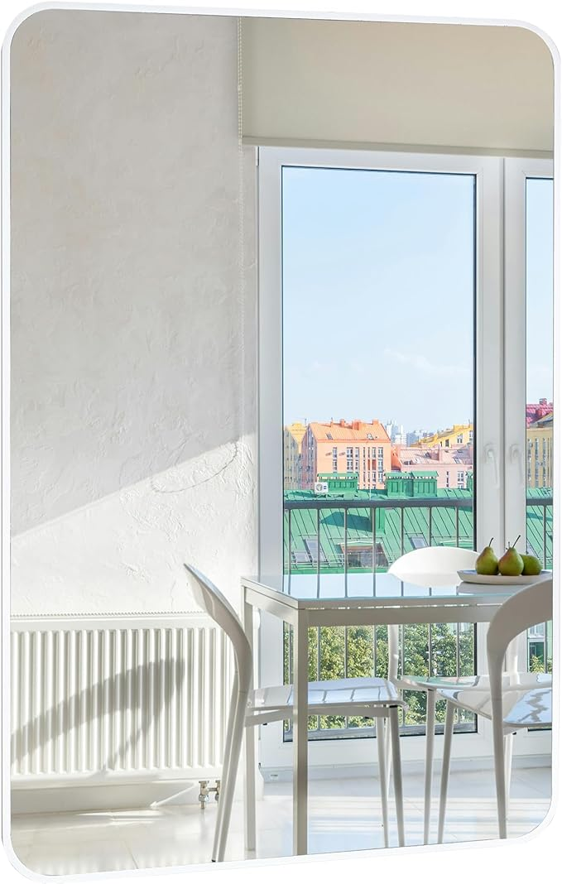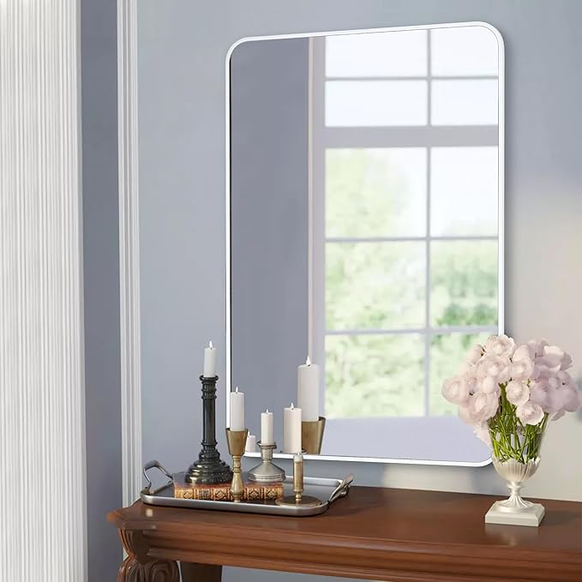

Tanmicoshomy White Bathroom Wall Mirror, Rectangular Vanity Mirror 24 x 36 Inches for Bedroom,Living Room or Entryway(24x36 inch, White)

**PRODUCT DESCRIPTION:**

|  |  |
| --- | --- |
| Brand | Tanmicoshomy |
| Room Type | Bahroom, Dressing Room, Bedroom, Hallway |
| Shape | Rectangular |
| Product Dimensions | 36"L x 24"W |
| Frame Material | Engineered Wood |

**About this item**

* White Mirror: The wall mirror features in pure white finish, choose from one of our beautiful finishes to complete your newly constructed or remodeled bathroom. With a simple, modern design, our 24x36 inch rectangle mirror is an elegant update to your home.
* Rectangle Mirrors for Wall: With a classic round corner design, the vanity mirror allows for creativity and functionality in the bathroom, bedroom, entryway, and anywhere else. Let your living space be an expression of your style, not limited to modern or contemporary, farmhouse or industrial.
* Tempered Glass: Different from other mirrors, our mirror is designed with 3mm tempered glass (shatter-proof, explosion-proof, sturdy, durable, and safe to use), which greatly reduces the damage to goods and delivers the mirror to customers in perfect condition.
* Easy Installation: The hook on the back of the mirror allows you to easily hang the mirror on the wall, that works horizontally or vertically.
* Professional Packaging：We understand the importance of packaging for wall mirrors,so in the past year, we have undergone three packaging renovations.The packaging of this wood mirror has been carefully designed to protect the mirror with all-round protection styrofoam,which passed drop and impact test.